**How to Install Kubernetes (k8s) 1.7 on CentOS 7 / RHEL 7**

Kubernetes is a **cluster** and **orchestration** engine for docker containers. In other words Kubernetes is  an open source software or tool which is used to orchestrate and manage docker containers in cluster environment. Kubernetes is also known as k8s and it was developed by Google and donated to “Cloud Native Computing foundation”

In Kubernetes setup we have one master node and multiple nodes. Cluster nodes is known as worker node or Minion. From the master node we manage the cluster and its nodes using ‘**kubeadm**‘ and ‘**kubectl**‘  command.

* Minikube ( It is a single node kubernetes cluster)
* Kops ( Multi node kubernetes setup into AWS )
* Kubeadm ( Multi Node Cluster in our own premises)

#### **On the Master Node following components will be installed**

* **API Server**  – It provides kubernetes API using Jason / Yaml over http, states of API objects are stored in etcd
* **Scheduler**– It is a program on master node which performs the scheduling tasks like launching containers in worker nodes based on resource availability
* **Controller Manager** – Main Job of Controller manager is to monitor replication controllers and create pods to maintain desired state.
* **etcd** – It is a Key value pair data base. It stores configuration data of cluster and cluster state.
* **Kubectl utility** – It is a command line utility which connects to API Server on port 6443. It is used by administrators to create pods, services etc.

#### **On Worker Nodes following components will be installed**

* **Kubelet** – It is an agent which runs on every worker node, it connects to docker  and takes care of creating, starting, deleting containers.
* **Kube-Proxy** – It routes the traffic to appropriate containers based on ip address and port number of the incoming request. In other words we can say it is used for port translation.
* **Pod** – Pod can be defined as a multi-tier or group of containers that are deployed on a single worker node or docker host.

### **Installations Steps of Kubernetes 1.7 on CentOS 7 / RHEL 7**

**Perform the following steps on Master Node**

#### **Step 1: Disable SELinux & setup firewall rules**

Login to your kubernetes master node and set the hostname and disable selinux using following commands

C:\Users\hl659qk\Pictures\b.PNG

#### **Step 2: Configure Kubernetes Repository**

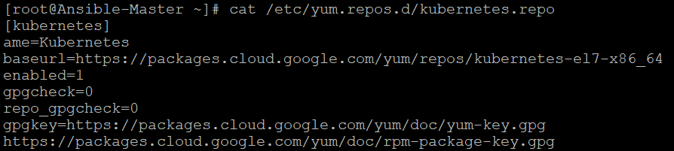

#### **Step 3: Install Kubeadm and Docker**

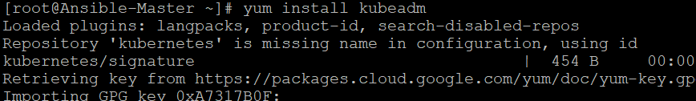

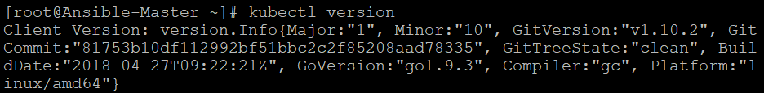

#### **Step 4: Now Join worker nodes to master node**

To join worker nodes to Master node, a token is required. Whenever kubernetes master initialized , then in the output we get command and token.  Copy that command and run on both nodes.

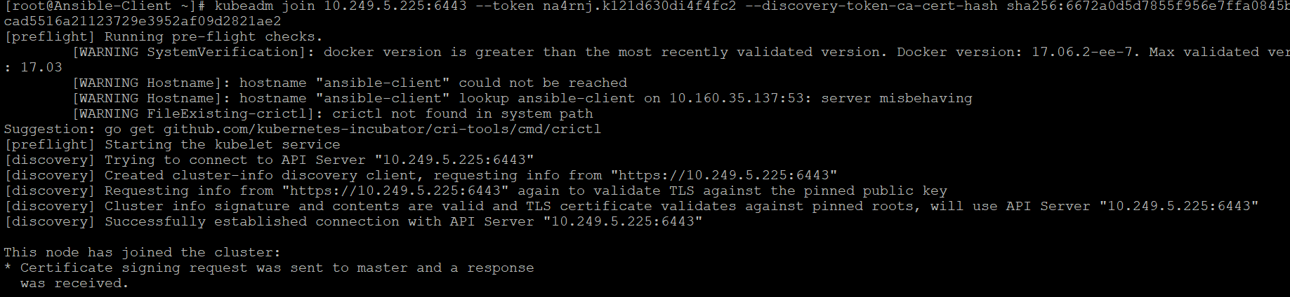

Now verify Nodes status from master node using kubectl command

